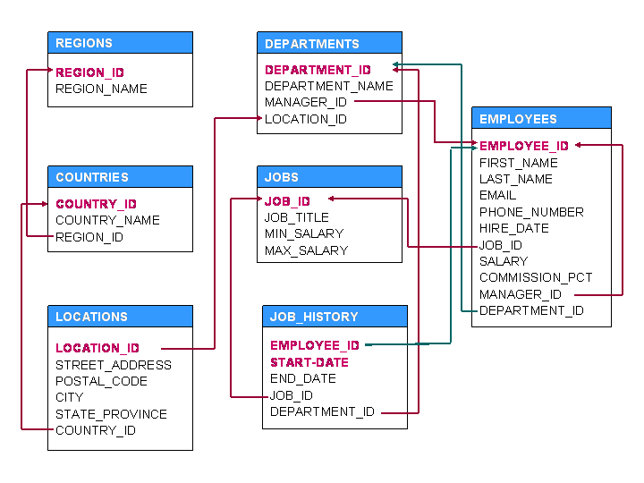

SET B

1. For each city find the minimum salary of IT Programmers(JOB_ID = 'IT_PROG') who have more than 5yrs of experience [experience is sysdate - employees.hire_date]. Print city name, corresponding maximum salary.
2. For each employee, find the total number of employees those were hired after him/her  
   But get more salary than him/ her.Print employee last name, total employees fulfilling the criteria.
3. Find the last names and salaries of those employees whose salary is within ± 5k of the average salary of SALES department.
4. For each job type, find the employee who gets the lowest salary. Print job title and first name of the employee. Assume that there is one and only one such employee for every job type.
5. For every city find the month when minimum hiring was done. Print city name, month name,and number of employee hired fulfilling the criteria.